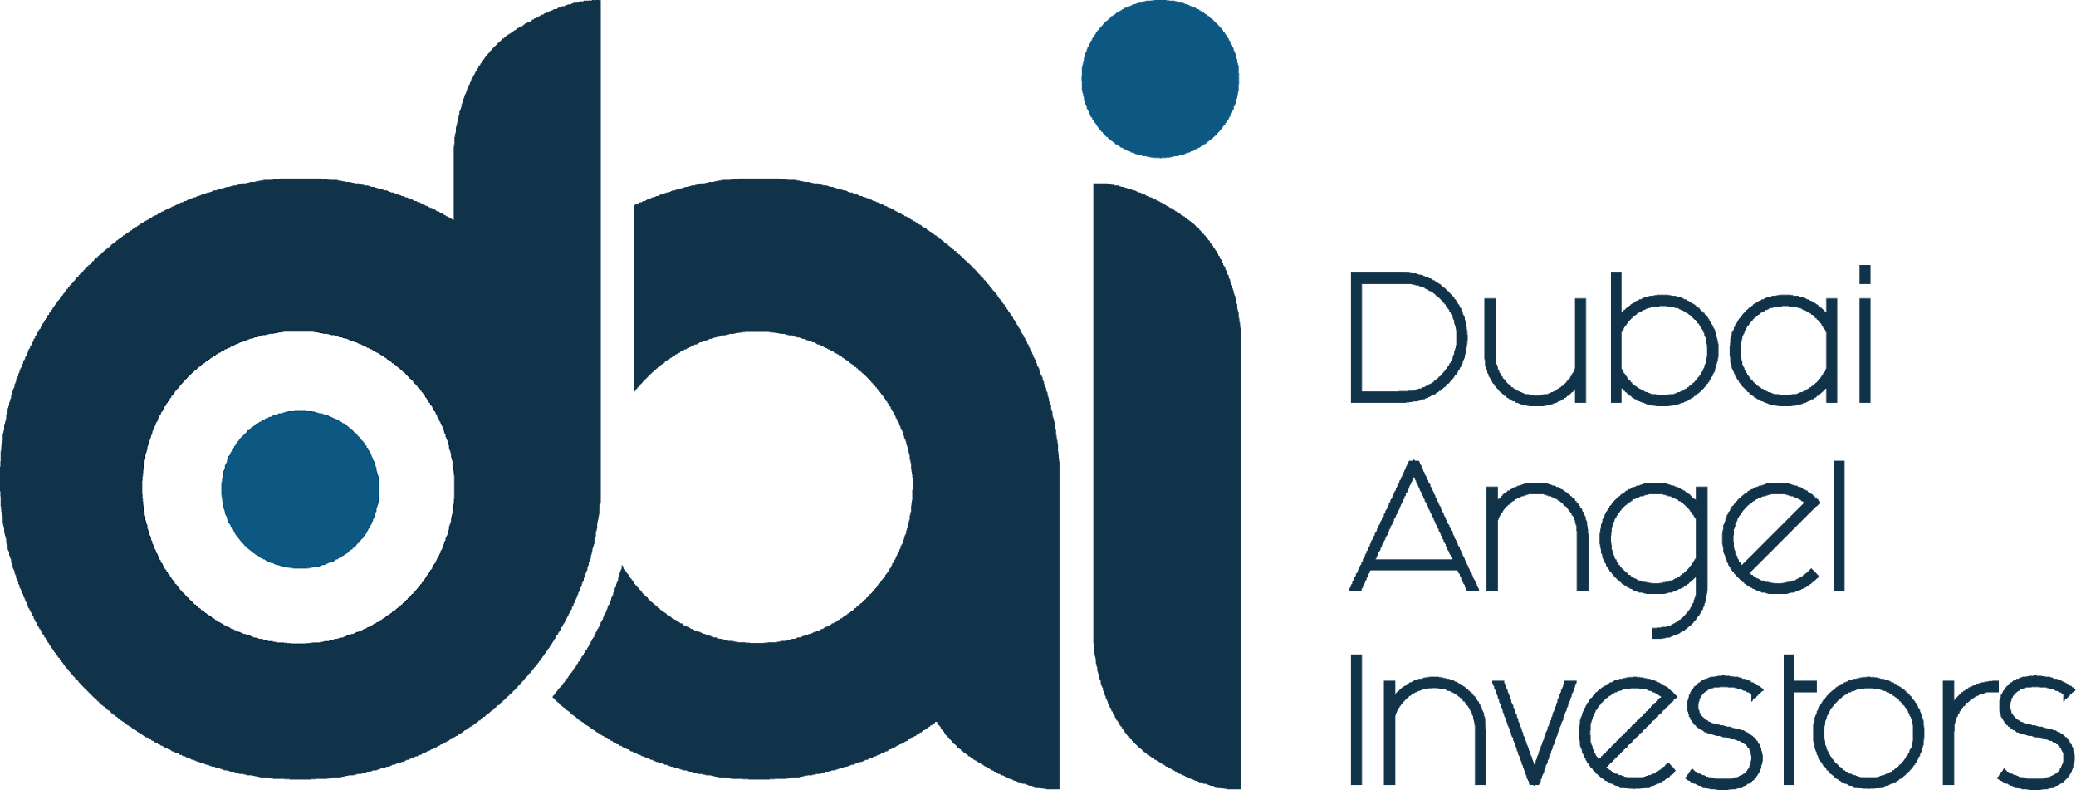

[INSERT NAME OF COMPANY APPLYING]
[ADD LOGO ABOVE NAME]

FUNDING APPLICATION FORM

INITIAL SCREENING

DAI will not consider startup companies that are not able to answer ‘YES’ to questions 1-5 below

A ‘YES’ response to questions 6-7 is not compulsory but will be an advantage

- Are you a client or consumer facing business that is in the technology space? YES / NO

- Do you have a minimum viable product or prototype with proof of concept? YES / NO

- Do you have initial traction with active paying or non-paying users? YES / NO

- Do you have more than one full time team member? YES / NO

- Is your business active in the MENA region? YES / NO

- Have you already raised some money for your startup? YES / NO

- Do you have a cofounder? YES / NO

COMPANY DETAILS
Company Name
Website URL
App (ios / Android)
Founded (Month / Year)
Company Address

Country / City / State
Management Address / location (if different)

Team Address / location (if different)

FUNDRAISING REQUIREMENT
Size of current funding round
Minimum amount needed
Maximum amount needed
Pre-Money Valuation (if set)
Amount already committed by other investors
Previous amount raised
Minimum Ticket (if set)

ELEVATOR PITCH
No more than 200 characters

DETAILED PITCH
No more than 2000 characters

LIST OF DOCUMENTS / MATERIALS SUBMITTED:

Document / Materials | Submitted with this application | We have not submitted this but we are able to if requested
Completed Application (this document) | Yes / No | Yes / No
Pitch Deck | Yes / No | Yes / No
Business Plan | Yes / No | Yes / No
Financial Model | Yes / No | Yes / No
Completed DAI Due Diligence Request | Yes / No | Yes / No
Product Video | Yes / No | Yes / No
Customer Testimonials | Yes / No | Yes / No
Other: Please Specifiy

